SHAKTI · SALES AUTOMATION
Sales CRM
One assistant replies instantly. Only real buyers reach your team.

Overview
Aria, an AI assistant, sits at the front of every channel — WhatsApp, Instagram, Facebook and web forms — and replies instantly, in the lead's own language. A fixed points formula and a five-gate rule, not the model's judgement, decide how serious a lead really is, so the same signals always produce the same verdict. Hot leads reach the sales team with a WhatsApp alert explaining why; the team can then run the whole CRM from short WhatsApp commands.

The Problem
A new enquiry can land on WhatsApp, Instagram, Facebook or a web form at any hour, and no sales team can answer every one the moment it arrives. By the time someone replies, an interested buyer has often gone quiet — while a good chunk of the team's day goes into triaging messages that were never going to sell. A CRM that only starts working once a person types a lead in misses the moment that matters most: the first reply.

How It Works
- Capture — a message arrives on any channel.
- Converse — Aria replies and qualifies it.
- Score — a fixed rule scores it 0–100.
- Route — hot leads go to sales, the rest get nurtured.
- Grow — automatic follow-ups and a daily digest keep the pipeline moving.
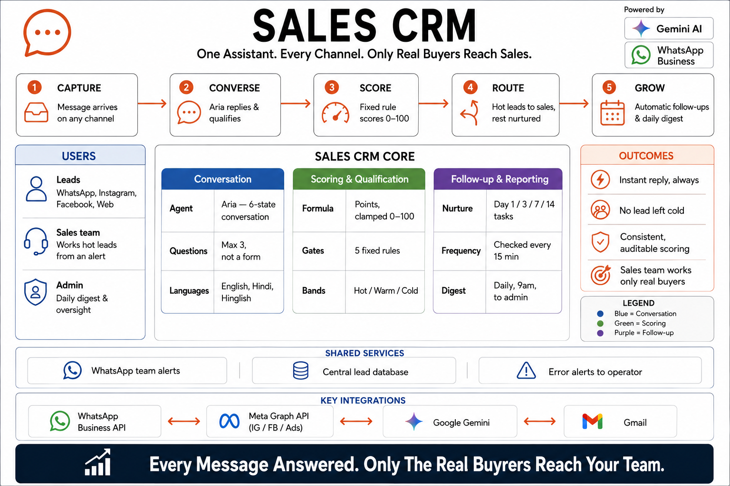
Figure 1. System architecture — conversation, scoring and follow-up, on WhatsApp, Meta, Gemini and Gmail.

Key Features
- A real conversation, not a form — Aria asks at most three questions across a whole conversation, replies in under 150 words, and matches the lead's language: English, Hindi or Hinglish.
- A fixed, explainable score — a points formula rates intent, urgency and contact details, and every score comes with a plain-language reason attached.
- Five checks before a lead reaches sales — promoted only once it clears fixed rules: not spam, genuinely engaged, a real buying signal, reachable.
- Every channel, one engine — WhatsApp, Instagram, Facebook, web forms and Meta Lead Ads all funnel into the same system.
- The team runs it from WhatsApp — short commands like UPDATE, NOTE, ASSIGN and REPLY manage leads without opening another app.
- Automatic nurture and a daily digest — leads that aren't ready get a day 1/3/7/14 follow-up sequence, and a WhatsApp summary lands with the admin each morning.

Who It's For
Any business getting more inbound messages than its sales team can personally triage. Today: a sports club's membership enquiries. Next: the same engine, built to serve other clients.

Aria in Conversation
A lead opens with a question; Aria replies in one line, asking exactly the qualifying question the scoring rules need. A couple of exchanges later, she closes the loop herself and hands off — “I'm connecting you with Rohan from our team.” The score the conversation just earned — 82, HOT — flows straight to Rohan's alert card. No form, and no manual triage in between.
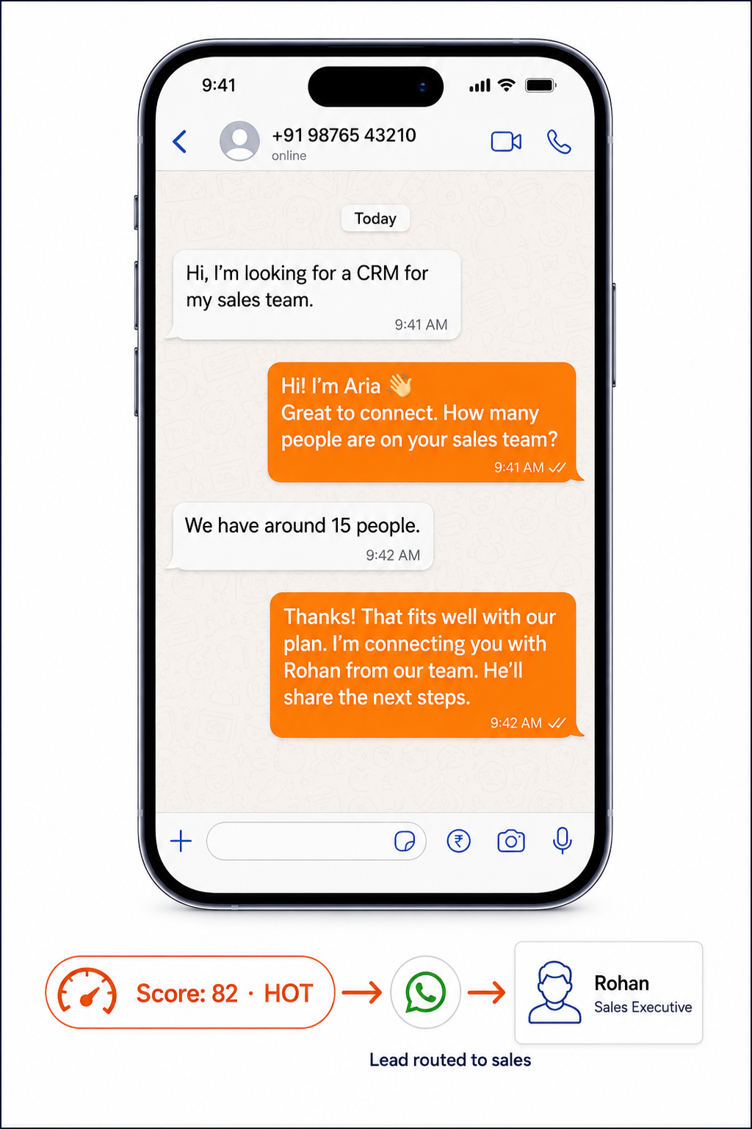
Figure 2. Aria qualifying and routing a lead, live on WhatsApp.

Integrations
Built on four outside services: the WhatsApp Business API for messaging, Meta's Graph API for Instagram, Facebook and Lead Ads, Google Gemini for the conversation, and Gmail. Leads are checked every 15 minutes; a shared database and WhatsApp alerts keep the whole team on the same picture, with errors flagged straight to the operator.

